**Telecommunication Software**

Fifth practical exercise

Full name: **Ergashev Nurmukhammad**

ID: **241AEM009**

**Riga 2024**

Contents

Example 1: Please test requests Python library 3

Example 2: Search engine keyword submission interface with requests python library. 4

Example 3: Image crawling. 4

Example 4: University ranking print 6

Example 5: Crawling of goods web pages and printing relevant numbers, goods names, and prices with requests from the Python library. 8

Example 6: Please reference two public projects finishing your Scrapy project 8

Conclusion 9

Source Code Repository 10

# Task 1: Binary Search Tree

Please create a binary search tree and node classes as I have shown in the lecture, including search, insert, delete, and traverse functions, using the following three lists to create the tree and combine the above-created function. For each step, please give an output or changed tree plot.

a = [49, 38, 65, 97, 60, 76, 13, 27, 5, 1]

b = [149, 38, 65, 197, 60, 176, 13, 217, 5, 11]

c = [49, 38, 65, 97, 64, 76, 13, 77, 5, 1, 55, 50, 24]

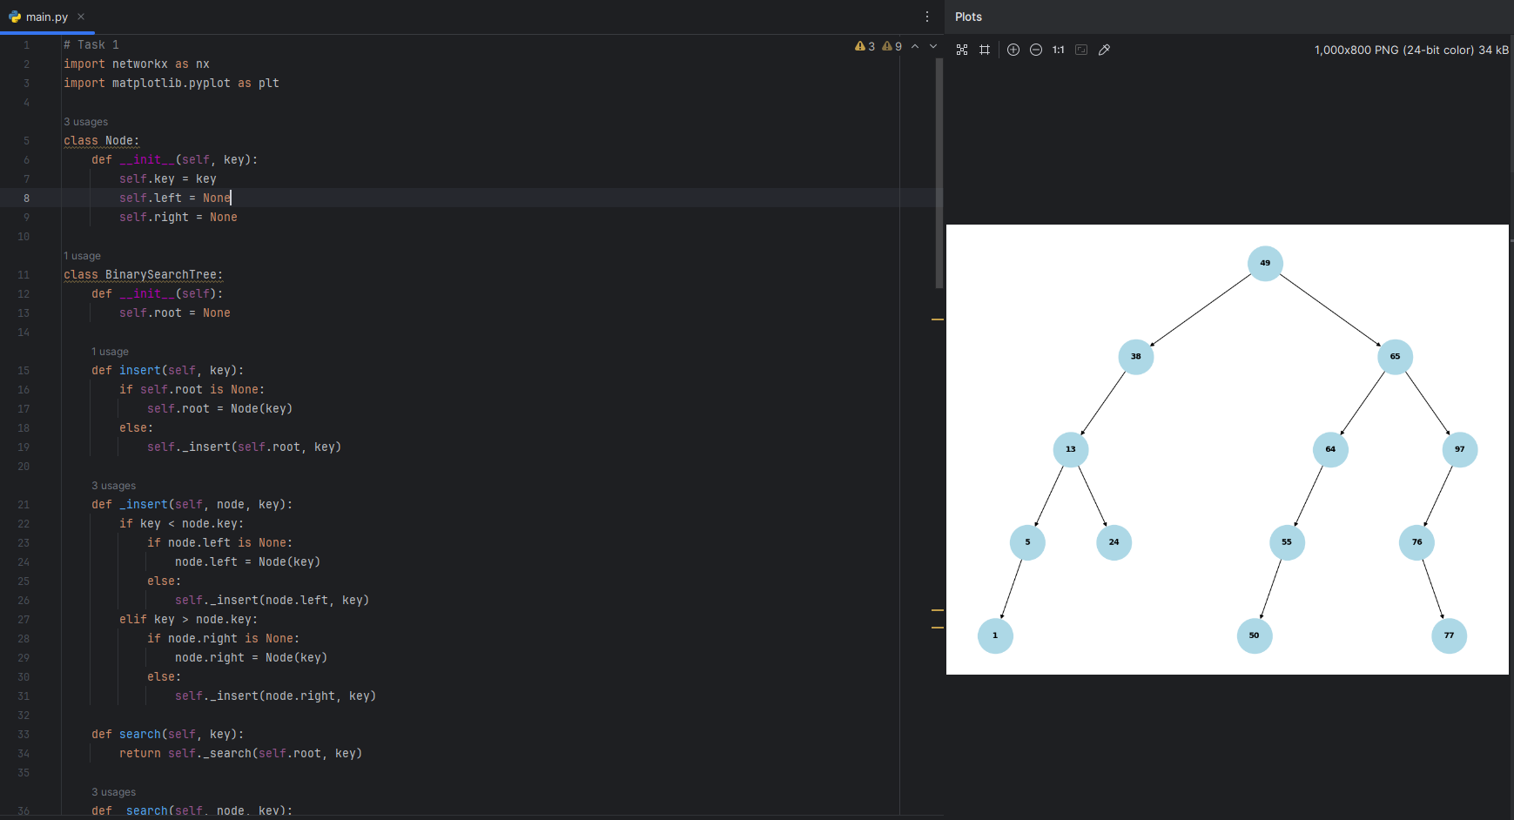

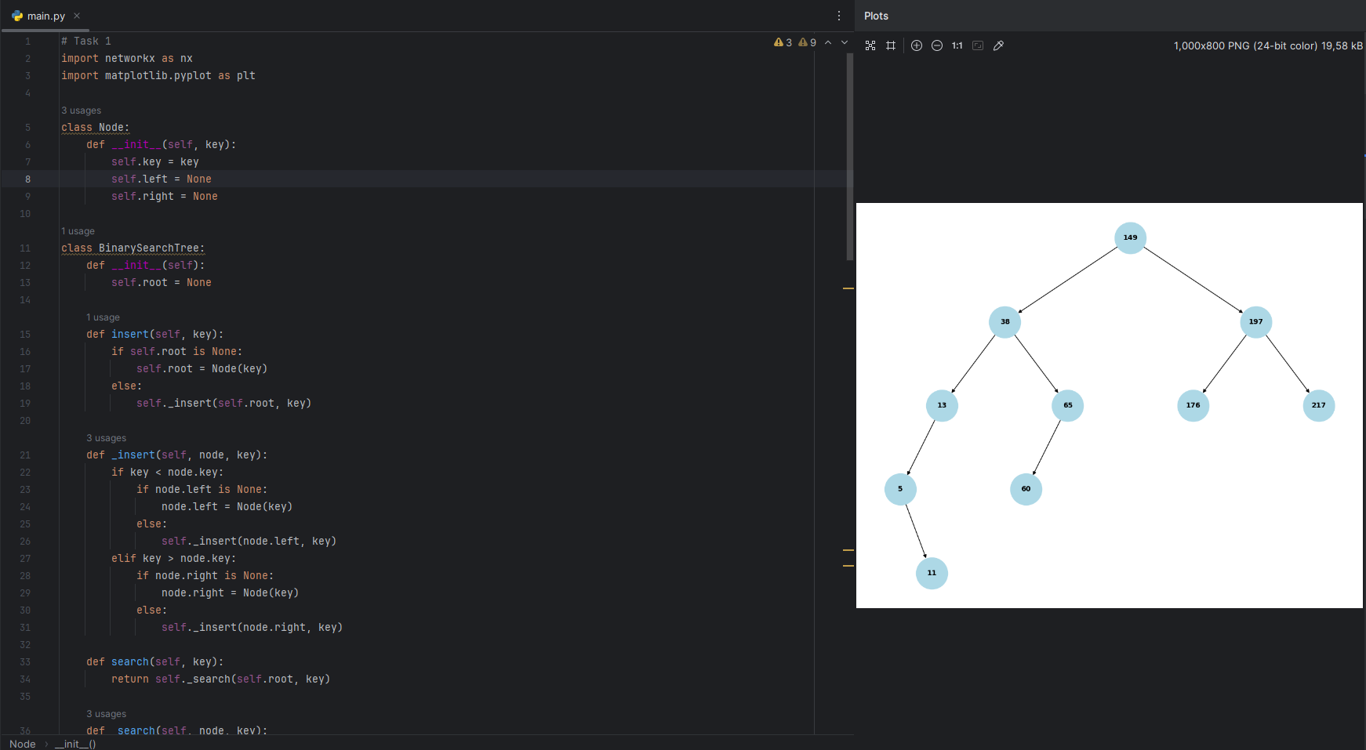

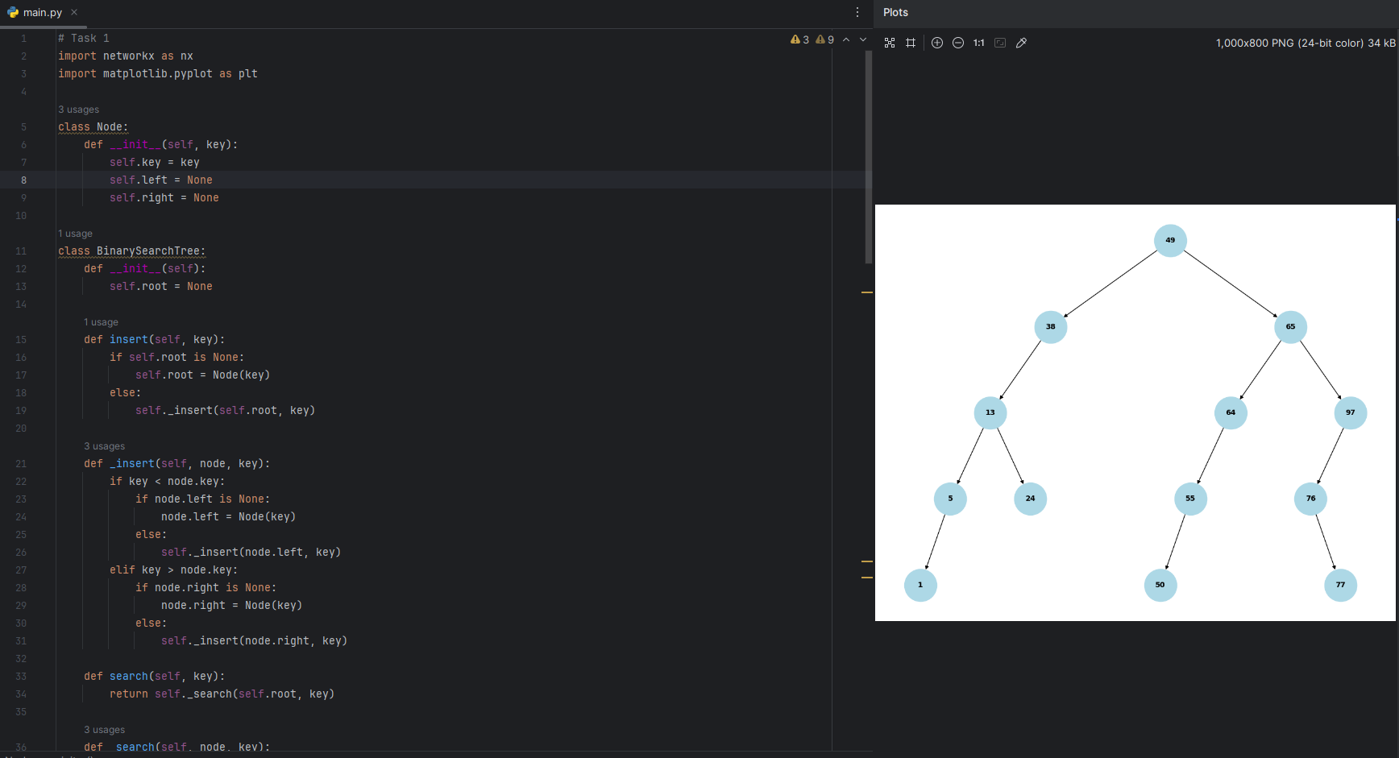

# Task 2: SDN Traffic classification with Decision Tree

Please use the second practical exercise's SDN traffic CSV file as your dataset, and make the traffic category/protocol classification with decision tree classifiers and obtain classification metrics, compare the ID3 and CART two algorithms' performance differences**.**

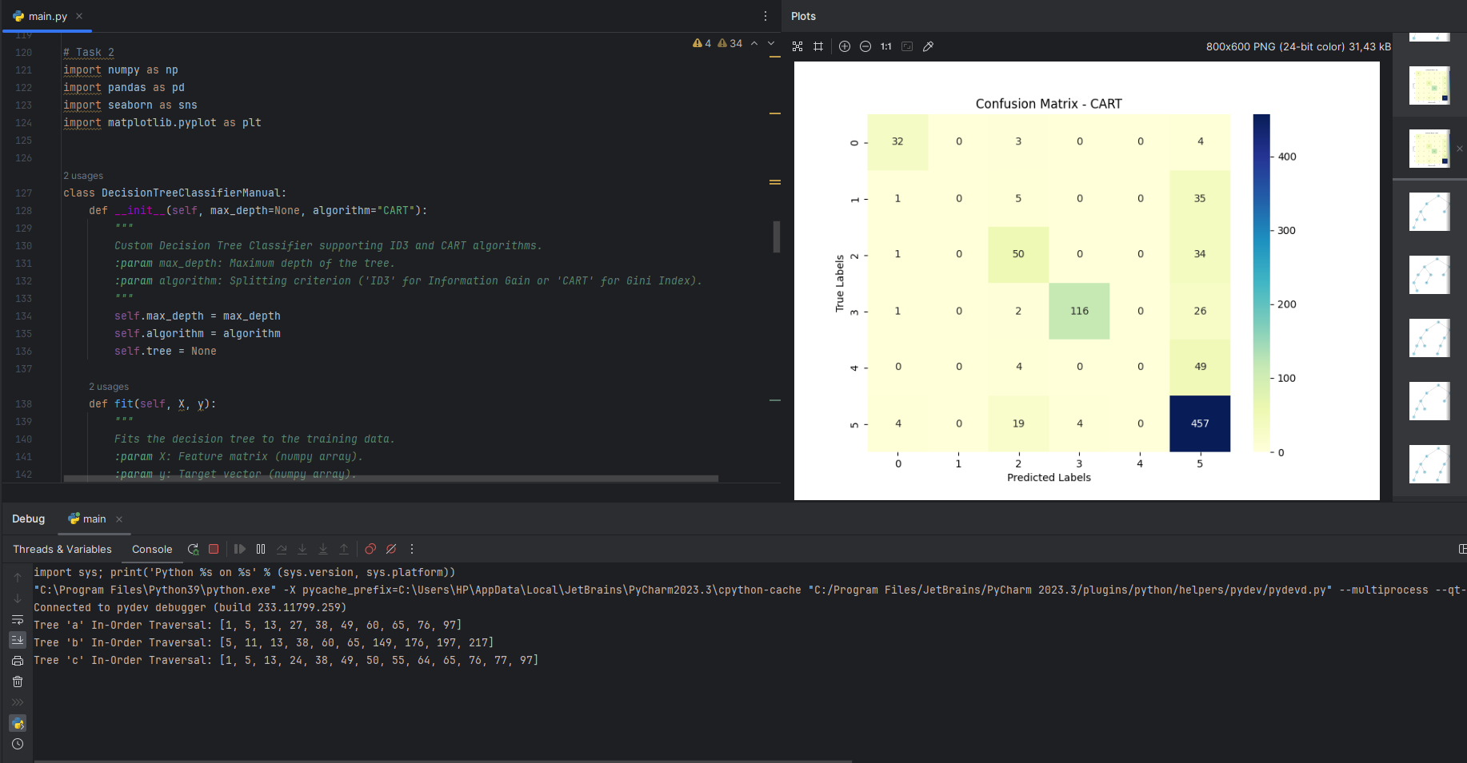

# Task3: Intrusion Detection (ISCXIDS2012 dataset)

Please use any decision tree or ensemble tree algorithms to finish the intrusion detection task, including malicious and normal classification, and minimize the false alert rate as much as possible.

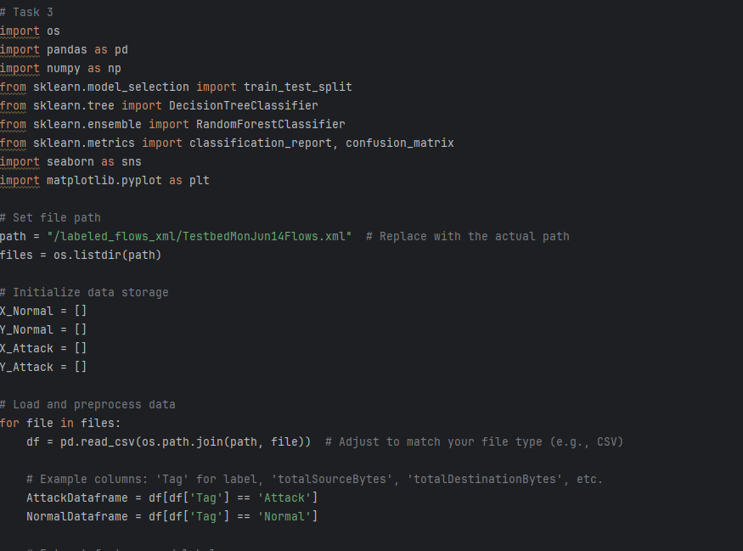

# Task4: Week's Network Traffic Prediction (ISCXIDS2012 dataset)

Please use any decision tree or ensemble tree regression algorithms to finish the week's network traffic prediction task, minimize the mean squared error, and improve the coefficient of determination regression score as much as possible.

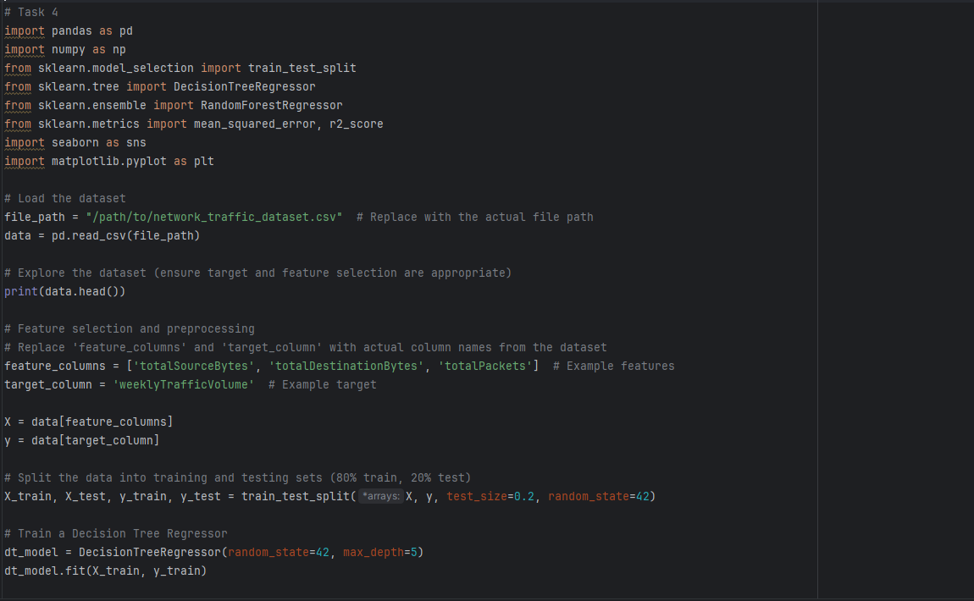

# Source Code Repository

All the source code for the examples discussed in this report has been uploaded to GitHub for reference and further development. The repository contains:

* Python scripts for each example.
* Dependencies and setup instructions.
* Sample outputs and data files.

Access the full repository here: [LINK HERE](https://github.com/ergashevnurik/ts_assignment4)